Wireless LAN

A wireless LAN or WLAN is a wireless local area network that uses radio waves or Infrared as its carrier .

Wireless Transmission Types
( Infrared , Radio )

Infrared | Radio
Many things absorb IR light (can’t penetrate walls, furniture etc. ) , Requires line of sight (LOS) | Can penetrate walls, furniture etc.
Example : Home-entertainment remote-control boxes | Example : Bluetooth

Characteristics | Wired | Wireless
Installation | Difficult | Easy
Cost | Less (such Ethernet, cables, switches are not expensive) | More (wireless adapters and access points are quite expensive )
Types | Local Area Network (LAN)  Metropolitan Area network (MAN)  Wide Area Network (WAN) | Infra-structure based network  Infra-structure less (ad hoc)
Standards | 802.3 | 802.11

Two Modes of IEEE 802.11

1. Infrastructure Mode : Terminals communicate to an access point.
Devices on the network all communicate through a single access point, which is generally the wireless router. For example, let’s say you have two laptops sitting next to each other, each connected to the same wireless network. Even when sitting right next to each other, they’re not communicating directly. Instead, they’re communicating indirectly through the wireless access point. They send packets to the access point — probably a wireless router — and it sends the packets back to the other laptop. Most Wi-Fi networks function in infrastructure mode.
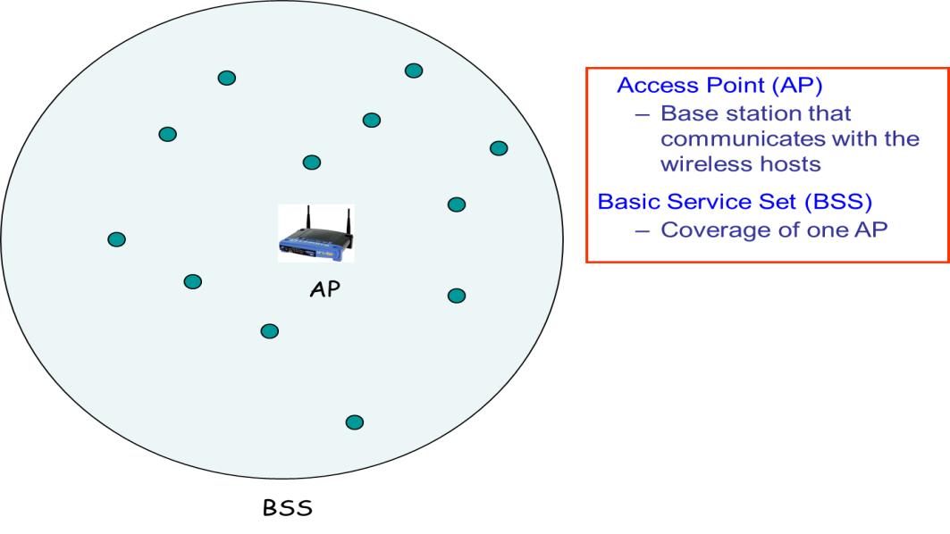
If nodes move out of range of the access point . Then communication is not possible!!
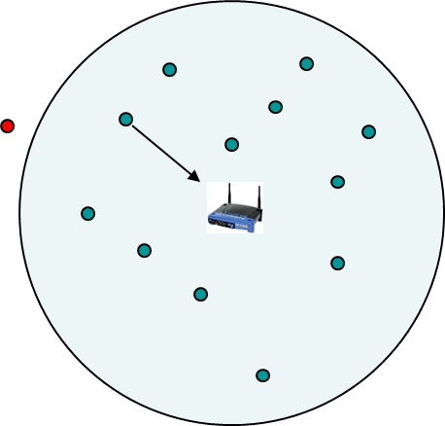

2. Ad Hoc Mode Terminals communicate in a peer-to-peer basis without any access point.
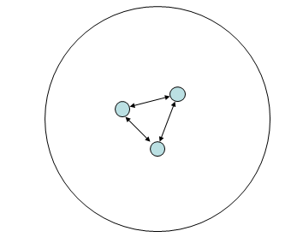
If Nodes are not in direct range of each other (Ad Hoc Mode). Then communication is not possible!!
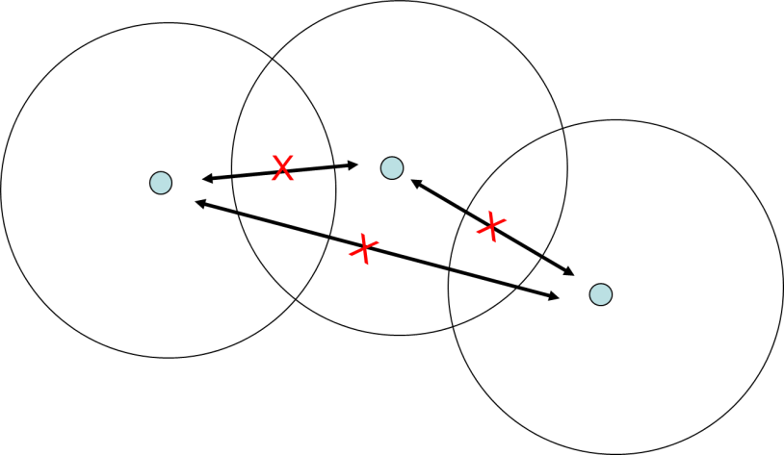

Why CSMA/CD is not applicable in WLAN

Wireless Properties
  - Signal strength decreases proportional to the square of the distance due to which there is a lack of full connectivity and Hidden Terminal Problem occurs
  - Exposed Terminal Problem
Due to these reasons we cant apply CSMA/CD properly

Hidden Terminal Problem ( A is hidden from C)

- A and B hear each other
- B and C hear each other
- But, A and C do not

  - A and C want to send to B
  - First A senses the channel got it free and send data to B
  - After that C senses the channel got it free as A is hidden from C and send data to B (CS fails)
Collision occurs at B.

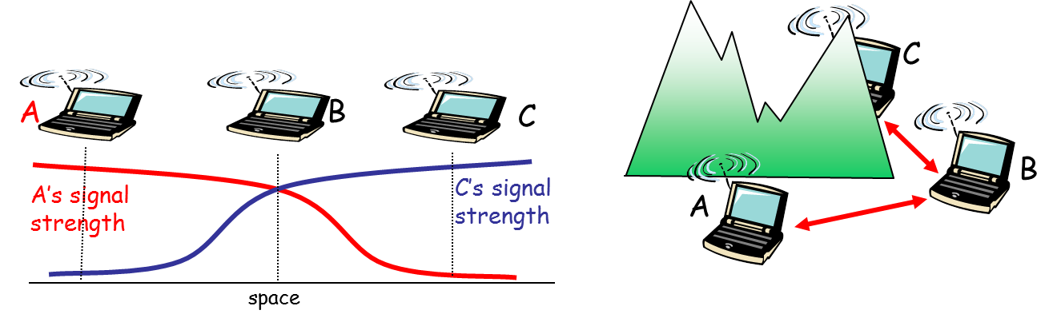

Exposed Terminal Problem

B wants to send to A, C wants to send to some other i.e not A not B
C has to wait, since he finds the medium in use due to the signals produced by B

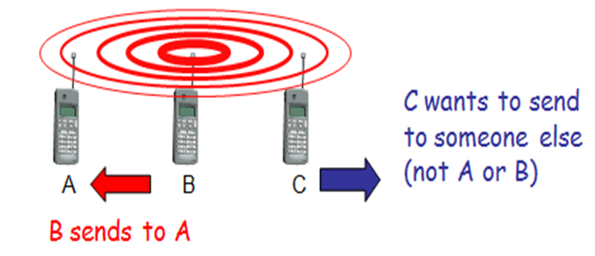

( MACA ) Multiple Access with Collision Avoidance

- IEEE 802.11 is based on the idea of MACA

- MACA uses a three-way handshake protocol
  - RTS (request to send) : sender sends RTS before sending data
  - CTS (clear to send) : receiver sends CTS
  - The sender then sends the data.

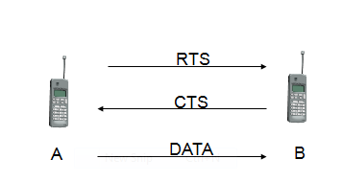

MACA Solution to hidden & exposed terminal problem

MACA avoids the problem of hidden terminals  - A and C want to send to B  - A sends RTS first  - Therefore B sends CTS to both A,C  - C waits after receiving CTS from B as in CTS senders and receivers address is there  - A sends data after getting CTS | 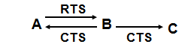

MACA avoids the problem of exposed terminals  - now C does not have to wait, as it cannot receive CTS from A | 