Cathode Ray Tube ( CRT )

Cathode ray tube is a vaccum tube containing one or more electron guns and a phosphorescent screen used to view images.

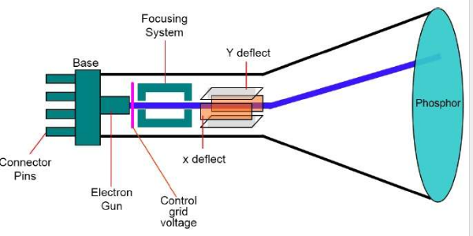

Horizontal deflecting plates are placed vertically and vertical deflecting plates are placed horizontally.
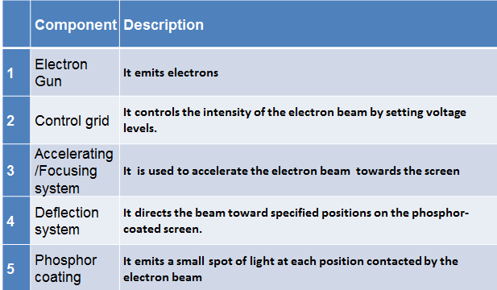

The operation of CRT is very simple –

- The electron gun emits a beam of electrons
- The electron beam passes through deflection systems that direct it towards specified positions on the phosphor-coated screen.
- When the beam hits the screen, the phosphor emits a small spot of light at each position contacted by the electron beam.
- It redraws the picture by directing the electron beam back over the same screen points quickly.

Detailed Explanation

1. Electron Gun- Narrow end of CRT contains a single electron gun for single-color monitor , Three electron guns for a color monitor—one each for three primary colors: red, green, and yellow . The Primary component of an electron gun is heated metal cathode .Heat is supplied to cathode by directing a current through a coil of wire called filament, this causes the electrons to be “boiled off” from cathode .The free negatively charged electrons are accelerated towards the phosphor coating .
2. Control Grid- Control Grid is used to control intensity of electrons/ brightness of display. It is also having negative charge. A high voltage on control grid will shut off the beam by repelling the electron whereas a smaller voltage on control grid simply decreases the number of electrons passing through. Therefore, intensity of electrons/ brightness of display is controlled by varying the voltage on control grid.
3. Accelerating anode : It is used to accelerate the electron beam towards the screen
4. Deflection systems : We know there are lot of pixels then how does the particular pixel will glow or you can say how does the electron beam hit to the particular phosphorus : This is done by deflection systems Magnets are used for this purpose . ( Electric Field can also be used for this purpose )
5. Phosphor When the electrons in beam collide with phosphor coating, they are stopped and their kinetic energy is absorbed by the phosphor and tend to move to higher quantum and back to ground state. During this phase energy is released causing phosphorus to glow
The light emitted by the phosphor fades very rapidly. One way to keep the phosphor glowing is to redraw the picture repeatedly. This is called a Refresh CRT Persistence: After how much time intensity becomes 1/10 th of original intensity. Lower persistence phosphors require higher refresh rates to maintain a picture on the screen without flicker.
There are two ways (Random scan and Raster scan) by which we can display an object on the screen.
Raster scan display :
The electron beam is swept across the screen one row at a time from top to bottom . As it moves across each row, the beam intensity is turned on and off to create the pattern of illuminated spots. This complete scanning of screen or frame once is called refreshing.. The refreshing rate or frame rate is normally 60 to 80 frames per sec or described as 60 to 80 HZ.
Picture definition is stored in memory area called the refresh buffer or frame buffer. This memory area holds the set of intensity values (0/1 0 means CRT off , 1 means CRT on ) for all the screen points.
On black and white systems, the frame buffer storing the values of the pixels is called a bitmap. Each entry in the bitmap is a 1-bit data which determine the on (1) and off (0) of the intensity of the pixel.
On color systems, the frame buffer storing the values of the pixels is called a pixmap. Each entry in the pixmap occupies a number of bits to represent the color of the pixel. For a true color display, the number of bits for each entry is 24 (8 bits per red/green/blue channel, each channel 2⁸=256 levels of intensity value, ie. 256 voltage settings for each of the red/green/blue electron guns).
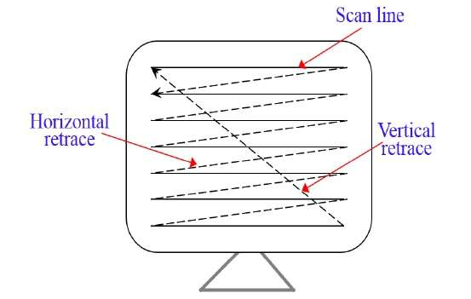
Picture Showing Horizontal And Vertical Retrace

On some raster-scan systems each frame is displayed in two passes using an interlaced refresh procedure. In the first pass, the beam sweeps across odd line from top to bottom. Then after the vertical retrace, the beam sweeps out the remaining even scan lines . Interlacing of the scan lines in this way allows us to see the entire screen displayed in one-half the time it would have taken to sweep across all the lines at once from top to bottom.

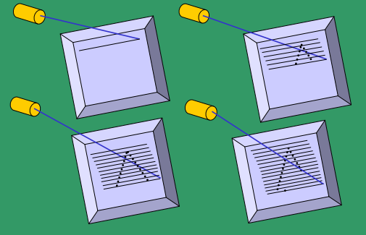

Graphics systems of raster-scan devices

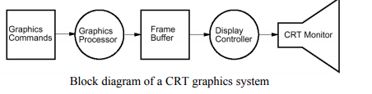

Graphics Processor : A graphics processor accepts graphics commands ( Draw point , Draw polygon , Draw text , Clear frame buffer , Change drawing color) from the CPU and executes the graphics commands and store the results of command to Frame buffer
Frame Buffer : The frame buffer acts as a temporary store of the image
Display controller/Display Processor : reads the frame buffer line by line and generates the control signals for the screen. The display processor is used to convert digital information from into analog value needed by the display device. This digital-analog conversion depends on the type of display devices used and the particular graphics functions that are to be hardware implemented

Random Scan Display (Vector Scan Display ) :
In this technique, the electron beam is directed only to the part of the screen where the picture is to be drawn rather than scanning from left to right and top to bottom as in raster scan. It is also calligraphic display.
Refresh rate on a random-scan system depends on the number of lines to be displayed.
Picture definition is now stored as a set of line-drawing commands in an area of memory referred to as the display file. To display a specified picture, the system cycles through the set of commands in the display file, drawing each component line in turn.
After all line- drawing commands have been processed, the system cycles back to the first line command in the list . (30 to 60 times each second.).

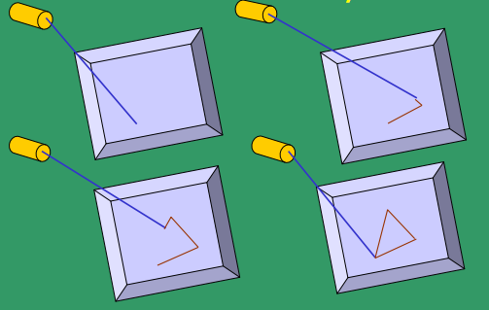

Different Between Random display and Raster Display

Random-scan generally have higher resolution than raster systems and can produce smooth line drawings
Random-scan systems were designed for line-drawing applications, such as architectural and engineering layouts, and they cannot display realistic shaded scenes.

Numerical

If the resolution is m*n and refresh rate is r fps
Total No of Horizontal retrace in one sec = (n-1)*r
Total No of vertical retrace is in one sec = (r-1)

1) How much time is spent scanning across each row of pixels during screen on a raster system with resolution of 1280 X 1024 and a refresh rate of 60 frames per second?
2) Let average time to execute any instruction in display program be 33.33 micro sec . If the frame rate (refresh rate) is 30 fps . Then what is the maximum no of instructions in the display program .
3) Suppose we have a video monitor with a display area that measures 12 inches width and 9.6 inches high. If the resolution is 1280 by 1024 , what is the diameter of each pixel
4) How long would it take to load a 640 x 480 frame buffer with 12 bits per pixel, if 10⁵ bits can be transferred per second?
5) Consider a raster systems with resolution of 800 x 400 .How many pixels could be accessed per second in each of these systems by a display controller that refreshes the screen at a rate of 60 frames per second? What is the access time per pixel in each system? (Hint: Access time =1/access rate )
6) Suppose RGB raster system is to be designed using on 8 inch x 10 inch screen with a resolution of 100 pixels per inch . If we want to store 6 bits per pixel in the frame buffer, how much storage (in bytes) do we need for frame buffer?

- Ans: 0.058 sec
- Ans: No of Instructions= 10⁶/( 33.33 * 30 ).
- Ans: Diameter= 0.009
- Ans: 36.8 sec
- Ans: 60*800*400
- Ans: 6 *10⁵ bytes

Look Up Table
If we want to represent color in 24 bits, and screen has 80x80 pixels, then frame buffer would need 24 bits per pixel, so total of 80x80x24 bits, which is lot of memory.

A solution to this is to use a lookup table. All the colors, 24 bit depth for example, are stored in lookup table.
The frame buffer just stores if index of the entry in the lookup table, to represent color. So, the advantage is that, the bits per pixel in frame buffer are only as large as the bits needed to represent index of lookup table.
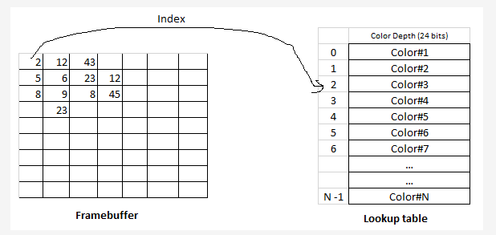
As can be seen above the frame buffer is just storing index of lookup table. The lookup table actually holds color representation. So size of frame buffer is reduced.
If the frame buffer has 8 bits per pixel and 8 bits are allocated for each of the R, G, B components, what would be the size of the lookup table?

This means that the each entry in lookup table is of 24 bits ( 8 bits for each RGB).
24 bits = 3 bytes.
So the size of lookup table is
Number of entries x size of each entry
256 entries x 3 bytes each entry = 768 bytes
Some Imp Terms

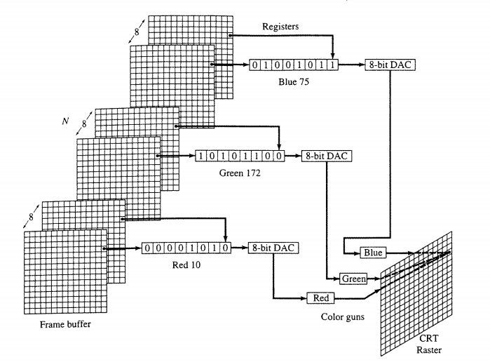
A frame buffer may be thought of as computer memory organized as a two-dimensional array with each ( x,y ) addressable location corresponding to one pixel.
Bit Planes or Depth is the number of bits corresponding to each pixel.
DAC Frame buffer is a digital device while the raster CRT is an analog device, conversion from a digital to analog signal is done by DAC

DVST (Direct View Storage Tube)

In both Random scan and Raster scan the screen image is maintained by redrawing the screen many times per second
An alternative way to maintain the screen image is to store the picture information inside the CRT instead of refreshing the screen
In DVST the image is stored in storage grid . Storage grid is a mesh grid coated with dielectric material.
Two guns are used namely Electron gun, Flood Gun .
Electron gun : When high speed electrons from electron gun hit the storage grid it displaces the electrons creating a positive charge.
Flood Gun: A flood gun is used for picture display. Now, the continuous flowing slow speed electrons from flood electron gun are attracted to the positively charged regions of the storage grid. They penetrate the storage grid and hit the phosphor coating in CRT generating the output.
Just behind the storage mesh is a second grid called the collector. The function of the collector is to smooth out the flow of flood electrons. Since a large number of electrons are produced at high velocity by the flood gun, the collector grid, which is also negatively charged reduces, the acceleration on these electrons and the resulting low velocity flood pass through the collector and get attracted by the positively charged portions of the storage mesh
Limitation of DVST is that
Modification of any part of picture requires redrawing of picture ( i.e generating new charge distribution on the storage mesh )

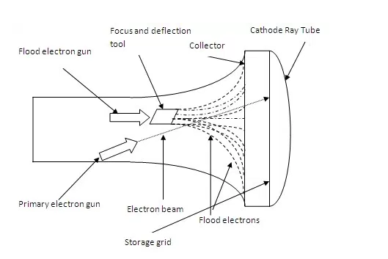

Color CRT

Two basic techniques used for producing color CRT displays are:
- Beam penetration Method
- Shadow-mask Method

In Beam penetration method, two layers of phosphor are there outer one is red and inner one is green and beam is penetrated through these layers , displayed color depends on how far the electron beam penetrates into the phosphor layer.
Slow electron Beam excites only the outer red layer
Very fast electron beam penetrates through red and excites the inner green layer.
Intermediate beam speeds produce combination of red and green light to show two additional colors, orange and yellow

It is an inexpensive way to produce color in random scan monitors, but only four colors are possible

Shadow-mask Method

Three electron guns are used .
Pixel is made of three phosphor dots ( red ,green , blue ) . The color of the pixel displayed depends on the intensity of the electron guns (what intensity you are using for red gun and so on ) .
High-quality raster-graphics systems have 24 bits per pixel (8 bits for each red ,green , blue i.e 2⁸= 256 levels of intensity for each electron gun nearly 17 million color choices for each pixel. (2^24 = 16777216 colors).

Shadow mask is used to ensure that each electron gun will hit its corresponding phosphor dot in the pixel .

