Network-Layer Routing

Routing tasks are methods of finding the paths for packet from their sources to their destinations. Routers are responsible mainly for implementing routing algorithms.

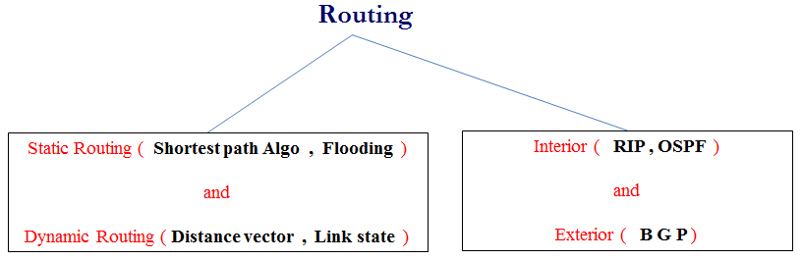

Static routing performs routing decisions with preconfigured routes in the routing table, which can be changed manually only by administrators. Static routes are normally implemented in those situations where there is no need for route change in the future. Also, if a failure happens in the network, it is unable to react immediately.
In dynamic routing , the state of the network is learned through the communication of each router with its neighbors. Dynamic routing continuously updates its routing table with paths and their cost/metric

Flooding

Flooding requires no network information whatsoever. Every incoming packet to a node is sent out on every outgoing line except the one it arrived on.
After the first transmission all the router which is 1 hop distance receive the packet.
After second transmission all the routers which are at 2 hop distance receive the packet.

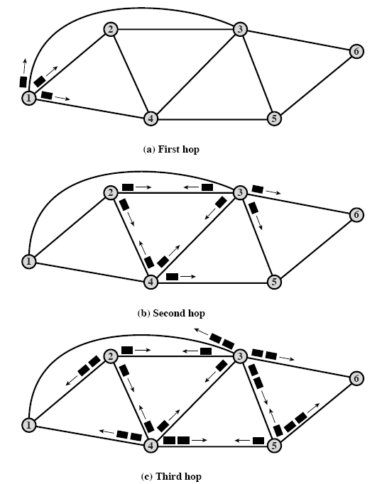

Limitation Of Flooding

Main limitation flooding is that it generates vast number of duplicate packets due to which bandwidth gets wasted. It is necessary to use suitable mechanism to overcome this limitation.

Solution

- Use hop-count: - A hop counter may be contained in the packet header, which is decremented at each hop, with the packet being discarded when the counter becomes zero.
- Use Sequence Number: - Avoid forwarding of same packet second time .

Distance Vector Routing Algorithm

- In routing table , initially each router Initialize neighbors with known cost, others with infinity .
- Periodically send copy of routing table to neighbors
- On reception of a table , if neighbors path to a destination plus neighbor cost is better, then switch to better path

 | Initial Table for A | Table for A after single iteration
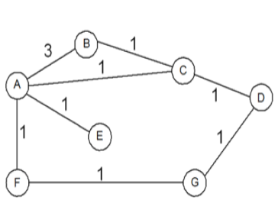 | 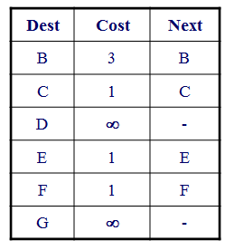 | 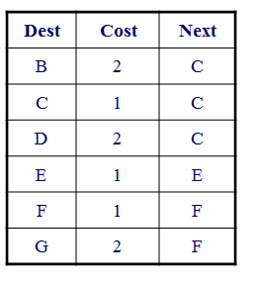

Discussed On Board
- Count to infinity Problem
- Differentiate b/w the technique used in Distance vector Routing and Link state Routing to build routing table
Study from Net
- Distinguish between Distance Vector Routing and Link State Routing

