National Institute Of Technology, Hamirpur Department Of Computer Science and Engineering
July-Dec 2017


Practical File

Subject Name: | Subject Code:
Course: | Semester:
Submitted By:  Student Name:  Roll No: | Submitted To:
Faculty Signature

S.No | Name Of Practical | Page No. |  | Signature
Write graphics program to draw the following by making the use of predefined functions
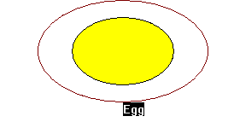
Line Drawing Algorithms
i) Write graphics program to draw a line on Screen using Digital Differential Analyzer ( D.D.A.) Line Drawing Algorithm
ii) Write graphics program to draw line on Screen using Bresenham's Line Drawing Algorithm.
Write graphics program to draw the following using DDA Line Drawing Algorithm
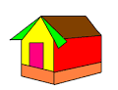
Circle Drawing Algorithms
- Write graphics program to draw circle on Screen using Midpoint Circle Generation Algorithm
- Write graphics program to draw circle on Screen using Bresenham's Circle Drawing Algorithm
- Write graphics program to draw seven concentric circles by using Midpoint or Bresenham's circle drawing algorithm
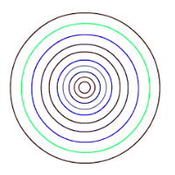
- Write graphics program to draw Olympic rings by using Midpoint or Bresenham's circle drawing algorithm

 | Write graphics program to implement Scan Line Polygon Filling Algorithm
 | Write graphics program to implement Boundary Fill Polygon Filling Algorithm
 | Write graphics program to implement Flood Fill Polygon Filling Algorithm
 | Write graphics program for bouncing ball animation

Practical – 1

Write graphics program to draw the following by making the use of predefined functions

Program:

#include <graphics.h>
#include <stdio.h>
#include <conio.h>

int main(void)

{

int gdriver = DETECT, gmode,errorcode ;
initgraph(&gdriver, &gmode, "C:\\TC\\BGI");
errorcode=graphresult();
if ( errorcode!= 0 ) /* an error occurred */
{
printf( grapherrormsg(errorcode));
printf("\nPress any key to halt:");
getch();
return 0;
}
printf("%d\n%d",getmaxx(),getmaxy());

setcolor(RED);
ellipse(getmaxx()/2,getmaxy()/2,0,360,100,60);
setfillstyle(1,WHITE);
floodfill(getmaxx()/2,getmaxy()/2,RED);

setcolor(BLACK);
ellipse(getmaxx()/2,getmaxy()/2,0,360,60,40);
setfillstyle(1,YELLOW);
floodfill(getmaxx()/2,getmaxy()/2,BLACK);
setcolor(WHITE);
outtextxy(getmaxx()/2,getmaxy()/2+60,"Egg");
getch();
closegraph();
return 0;
}

Output

Practical – 2

Line Drawing Algorithms

i) Write graphics program to draw a line on Screen using Digital Differential Analyzer ( D.D.A.) Line Drawing Algorithm

ii) Write graphics program to draw line on Screen using Bresenham's Line Drawing Algorithm.

Program:

