Architectural Styles
From Architectural Styles we come to know that how the system is builded i.e what components are used , How components are organized, how components communicate, how data is manipulated . Different types of Architectural Styles are:
- Pipes and Filters
- Object-Orientation based
- Event-Based , Implicit Invocation based
- Layered Systems based
- Repositories based
- Interpreters based

Pipes and Filters

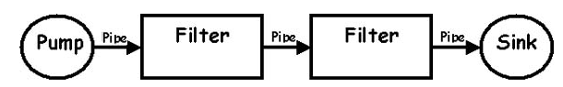
The filter transforms or filters the data it receives via the pipes with which it is connected. A filter can have any number of input pipes and any number of output pipes.
The pipe is the connector that passes data from one filter to the next.
The pump or producer is the data source. It can be a static text file, or a keyboard input device, continuously creating new data.
The sink or consumer is the data target. It can be a another file, a database, or a computer screen.
Example;
- Unix programs : The output of one program can be linked to the input of another program.
- Compilers : The consecutive filters perform lexical analysis, parsing, semantic analysis, and code generation.

Properties:
Filters don’t need to know anything about what they are connected to
Filterscan be implemented in parallel
Behaviour of the system is the composition of behaviour of the filters

Event Based , Implicit Invocation

Rather than invoking a procedure directly or sending a message a component announces, or broadcasts, one or more events .
Other Components register interest in an event by associating a procedure with the event ,Announcers of events do not know which components will be affected by those events
Examples:
Š Editor announces it has finished editing a module, compiler registers for such announcements and automatically re-compiles module.

Strengths
Add and replace components with minimum affect on other components in the system
Weaknesses
Loss of control when a component announces an event, it has no idea what components will respond to it .

Repository

Components:
- A central data structure representing the correct state of the system.
- A collection of independent components that operate on the central data structure.
Connectors:
- Typically procedure calls or direct memory accesses.

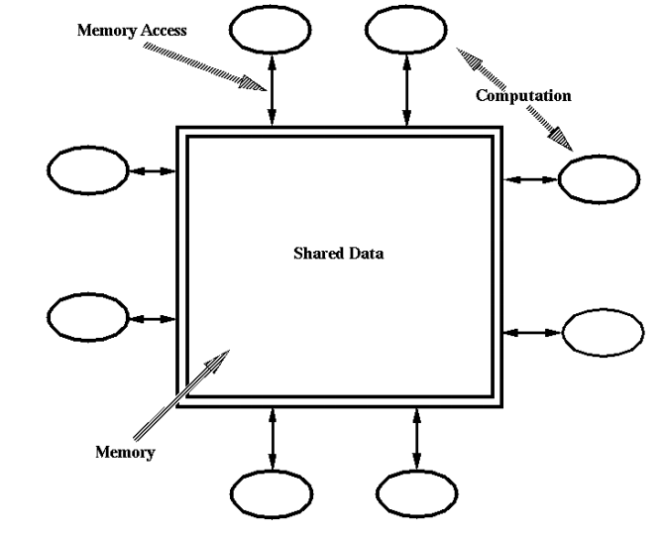
Example
Information systems
Advantages
Efficient way to store large amounts of data.
Sharing model is published as the repository schema.
Centralized management for
  - backup,
  - security
  - concurrency control
Repository disadvantages
Must agree on a data model a prior
Difficult to distribute data
Data evolution is expensive

Process Control Architecture Style

Suitable for applications whose purpose is to maintain the outputs of the process near given reference values.

Set Point is the desired value for a controlled variable
Controlled variable : Output Variable whose value need to be controled
Input variable : input to the process.
Manipulated variable : whose value can be changed by the controller

Two Types Of Control System

Feed-Back Control System
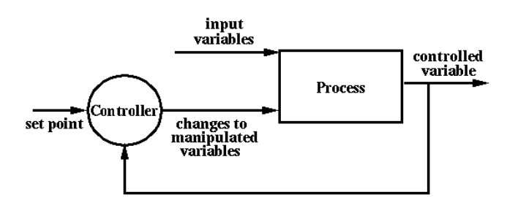

Open-Loop Control System

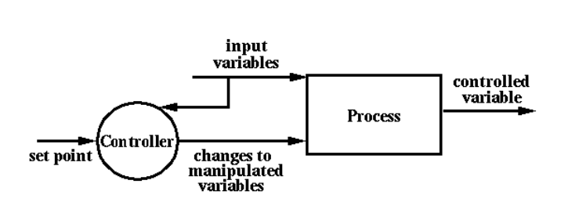

Heterogeneous Architectures

Locationally heterogeneous
A branch of a call-and-return system may have a shared repository (i.e Obect Oriented Style + Repository Style )

Simultaneously heterogeneous
Two or more architectural styles may both be appropriate for the style used by a system.

Hierarchically heterogeneous
A Component in one style may have an internal structure developed in a completely different style e.g pipe component developed in OO style .

Software Qualities

Functionality
Functionality is expressed as a totality of essential functions that the software product provides
For example a sales order system should also provide the following functions:
- Record sales order product, price and quantity.
- Calculate total price.
- Calculate appropriate sales tax.
- Calculate date available to ship, based on inventory.
- Generate purchase orders when stock falls below a given threshold.

Reliability
Once a software system is functioning, as specified, and delivered the reliability characteristic defines the capability of the system to maintain its service provision under defined conditions for defined periods of time.
One sub characteristic of this is fault tolerance that is the ability of a system to withstand component failure. For example if the network goes down for 20 seconds then comes back the system should be able to recover and continue functioning.

Usability
Usability only exists with regard to functionality and refers to the ease of use for a given function. For example a function of an ATM machine is to dispense cash as requested. Placing common amounts on the screen for selection, i.e. $20.00, $40.00, $100.00 etc, does not impact the function of the ATM but addresses the Usability of the function.
The ability to learn how to use a system (learnability) is also a major sub characteristic of usability.

Changeability
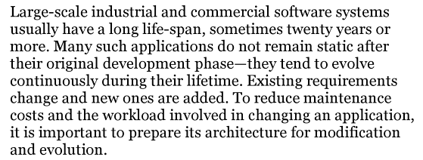
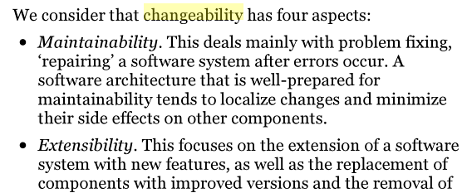
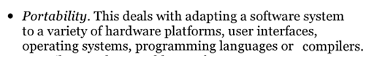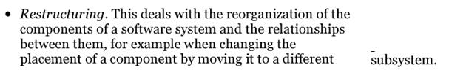

Interoperability

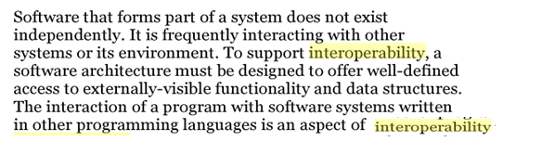

Effeciency
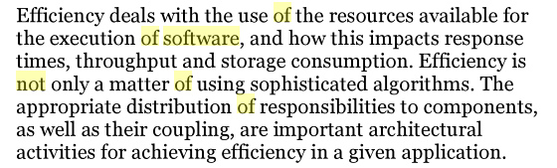

Testability
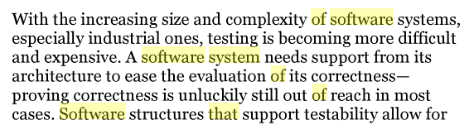

Reusability
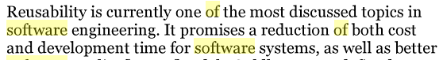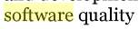

Tactics to achieve software qualities

Software Architecture Reconstruction

“Software architecture reconstruction is a process of obtaining the documented architecture of an existing system.”

Some Sources of input for reconstruction
- The system itself
- Traces obtained by executing the system

Two Software Reconstruction Methodologies
- Symphony : View-Driven Software architecture reconstruction
- Cacophony: Metamodel-Driven Software architecture reconstruction

Symphony
Symphony It is a View-Driven Software architecture reconstruction
Software architecture is usually described in terms of models .
Symphony tries to reconstruct these models . Symphony makes use of viewpoints and views to construct and present these models.

Viewpoint : Front View
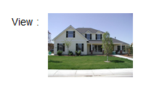
A Viewpoint is more generic, a view is with respect to a given entity

Main Views In Symphony
- Source View: The view of the system derived from the artifacts of the system ,like source code, documentation, build files .
- Target View: This is the final view that we need . It contains the information needed to solve the problem .
- Hypothetical View: This reflects the current understanding of the architecture – usually not accurate.

Symphony Steps
Reconstruction Design
Identify potential useful Viewpoints
- Define/Refine Target Viewpoints
- Define/Refine Source Viewpoints
- Define/Refine Mapping rules

Reconstruction Execution: produces the final architecture .

Cacophony
Cacophony : Metamodel-Driven Software architecture reconstruction
Model : A model is a simplification of a system with an intended goal in mind. This model should be able to answer questions in the place of the actual system
Metamodel: A metamodel is a model that defines the language for expressing a model
Appliware: It is the set of software applications developed by a givenCompany
Metaware: It is the software to develop appliware and to control its Evolution

Cacophony- Steps
Metaware domain and asset analysis
- Metamodel recovery
- Metamodels integration
- Metamodel clustering
Metaware requirement analysis
- Meta-level actor identification
- Meta-level use case identification
Metaware specification
- Meta-model filtering and extension
Conclusion

- Cacophony and Symphony are pretty similar.

- In Symphony we concentrate on a collection of views whereas in cacophony the focus is on metamodels.

- Symphony starts from the scratch and takes an incremental approach to software architecture reconstruction whereas cacophony focuses on reusing the existing metaware.

Phases of Reconstruction

Architecture reconstruction is an iterative and interactive process, comprising four phases.
The first phase is the extraction of a set of extracted views that represent the system's fundamental structural and behavioral elements.
The second phase is fusion of the extracted views to create fused views that augment or improve the extracted views.
During the third phase, the analyst iteratively and interactively develops and applies patterns to the fused views to reconstruct architecture-level derived views. Patterns provide the medium for an analyst to express their understanding of a system’s architecture as structural and attribute-based relationships among its components.
Finally, the derived views may be explored for the purposes of evaluating architectural conformance, identifying targets for reengineering or reuse, and analyzing the architecture's qualities.

Uses of Reconstruction
Software architecture reconstruction provides important leverage for the effective reuse of software assets (a useful or valuable quality) .
The ability to identify the architecture of an existing system that has successfully met its quality goals fosters reuse of the architecture in systems with similar goals .

