When light fall on the surface depending upon the nature of surface it is absorbed or reflected It is the reflected light which makes the object visible. If all the incident light energy is absorbed the object is invisible. The object is then called black body.

Types of reflection
Diffused Reflection
When light is incident on irregular surfaces
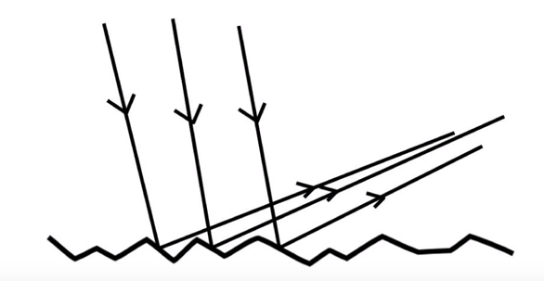
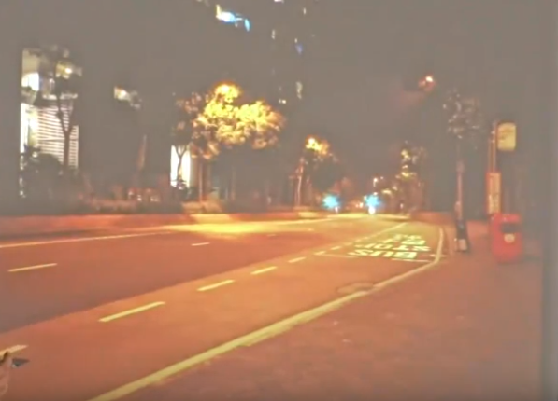
Specular Reflection
When light is incident on smooth polished and regular surfaces

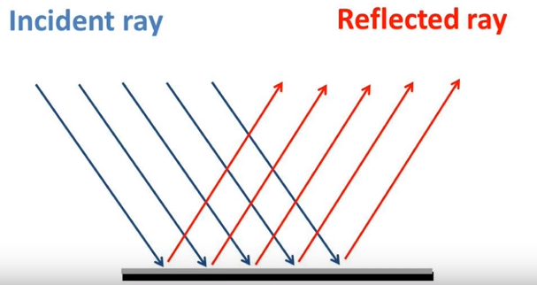
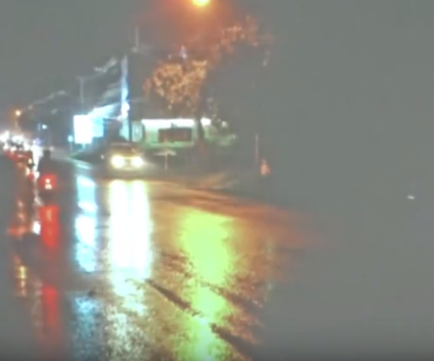

Ambient Reflection
That reaches our eye after bouncing off from many surfaces first.
Illumination models are used to calculate the light intensities which we should see at given point on surface of an object. As per Phong Illumination model the intensity of realistic image is the sum of all three reflections. ( Don’t
Ambient Component | 
Diffused Component | 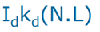
Specular Specular Component Component | 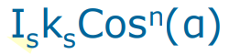

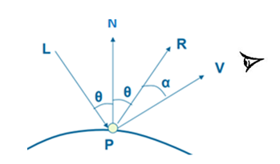
K= coefficient
N= normal vector
L = Light source vector
R=Reflection vector
V=Line of Sight
n gives the sharpness
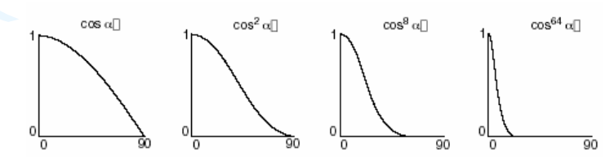

Consider a screen with resolution 512 * 512 .If there are total 256 depth values and 512 intensities are possible .How much total memory is needed in Z buffer algo in order to maintain the buffers. .

Polygon Rendering/Shading Method
Illumination model is used to render graphics objects which are formed with the polygon surfaces but calculating intensity at each visible point & applying desired illumination model at that point is expensive.
Therefore we apply Constant Intensity Shading: (Flat Shading) or Interpolated Shading techniques to achieve Polygon Rendering

Constant Intensity Shading: (Flat Shading)
Color is computed once (i.e. for one point ) for each polygon and then entire polygon is drawn with that color. Drawback of this shading is intensity discontinuity.
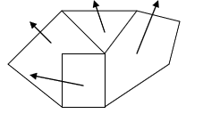
Interpolated Shading
An alternative to evaluating an illumination equation at each point on polygon, we can use interpolated shading, in which shading information is linearly interpolated across the polygon. Gouraud Shading and Phong Shading comes under this category.

For details about Gouraud Shading and Phong Shading please refer the link
https://kullabs.com/classes/subjects/units/lessons/notes/note-detail/4872

