LIST OF PRACTICALS

S.No | Name Of Practical
Write graphics program to draw the following by making the use of predefined functions
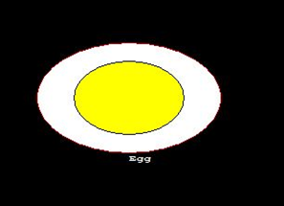
Line Drawing Algorithms
i) Write graphics program to draw a line on Screen using Digital Differential Analyzer ( D.D.A.) Line Drawing Algorithm
ii) Write graphics program to draw line on Screen using Bresenham's Line Drawing Algorithm.
Write graphics program to draw the following using DDA Line Drawing Algorithm
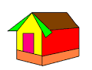
Circle Drawing Algorithms
- Write graphics program to draw circle on Screen using Midpoint Circle Generation Algorithm
- Write graphics program to draw circle on Screen using Bresenham's Circle Drawing Algorithm
- Write graphics program to draw seven concentric circles by using Midpoint or Bresenham's circle drawing algorithm
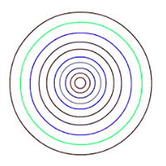
- Write graphics program to draw Olympic rings by using Midpoint or Bresenham's circle drawing algorithm
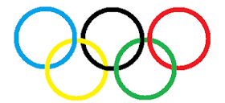
 | Write graphics program to implement Scan Line Polygon Filling Algorithm
 | Write graphics program to implement Boundary Fill Polygon Filling Algorithm
 | Write graphics program to implement Flood Fill Polygon Filling Algorithm
 | Write graphics program for bouncing ball animation
 | Write graphics program for moving car in animated rain ,also control the movement of car using keys of keyboard

