DNS

So DNS is A client-server application that maps domain names into their corresponding IP addresses with the help of name servers. Mapping domain names into their corresponding IP addresses is called name resolution or Address Resolution or name translation or name mapping
Types Of Name Servers
Root Name Servers
  - “. “ Servers
  - As of February 2013, there are 13 root name servers in the world
Top Level Name Server (Intermediate Name Server)

Authoritative name server:
- Stores host’s IP address, name . So can perform name resolution

Local name servers:
- Each ISP, company has name server known as Local NS
Two things to keep in mind
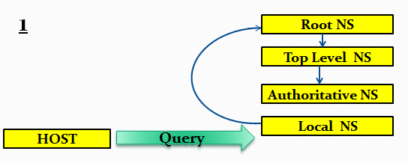
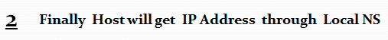
Name Resolution
Mapping domain names into their corresponding IP addresses.This technique of Name Resolution is of two types :
- Iterative resolution:- Iterative servers don’t know how to ask others for information they can only answer if they have information in its database .No Caching
- Recursive resolution:-Recursive servers know how to ask others for information .Caching is there in Recursive resolution.

Which one is better Iterative resolution or recursive resolution?

Recursive is better because
- Due to its caching property
- If distance is more than iterative takes very much time to resolve

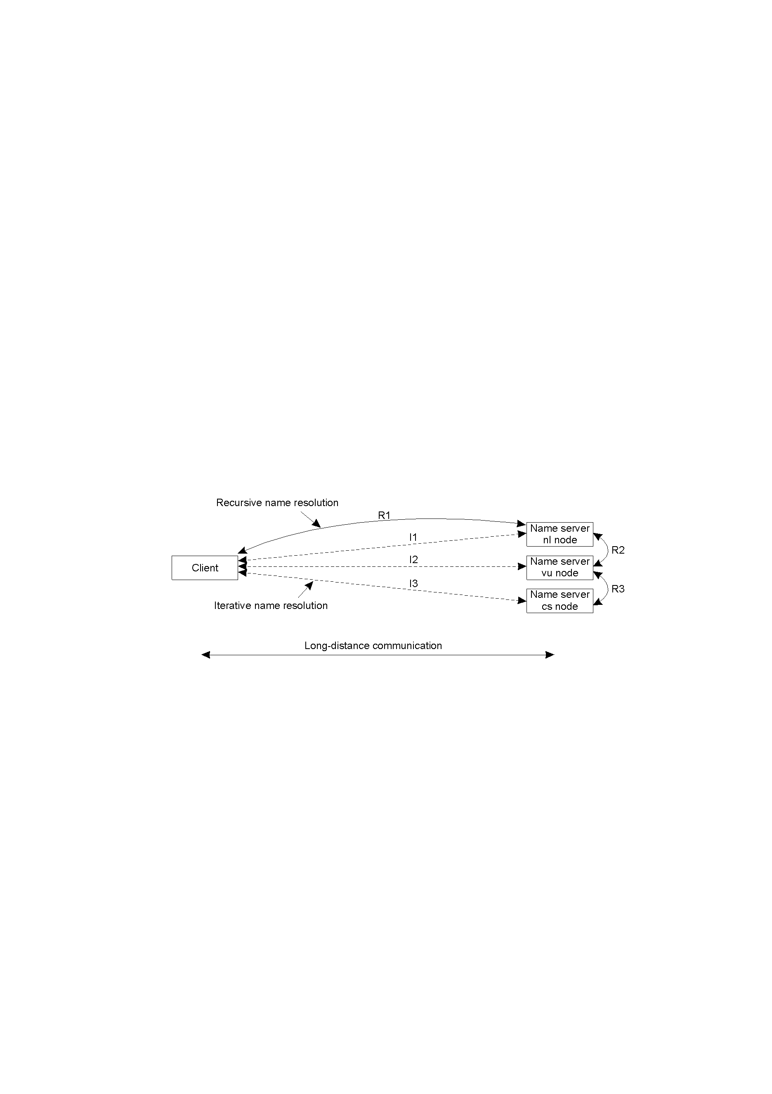

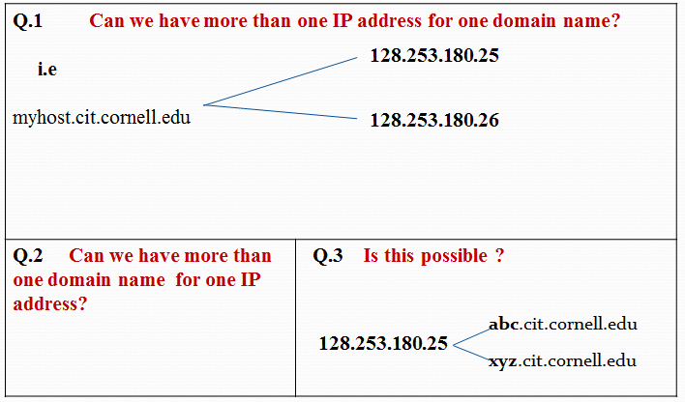

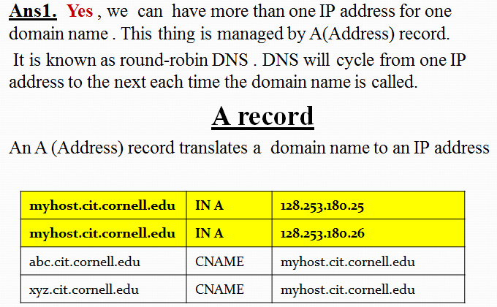

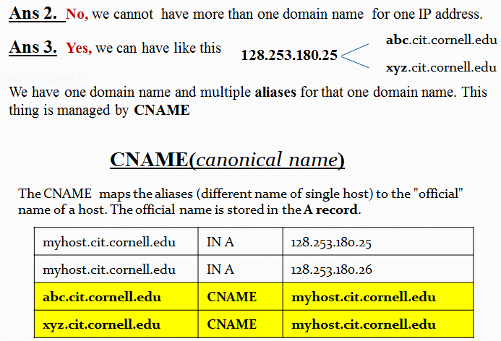

HTTP

Protocol used for communication between web browsers and web servers. It is stateless protocol.
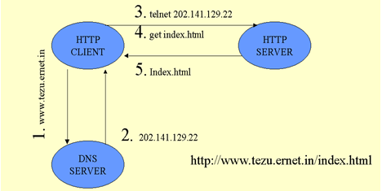  4. Index.html | 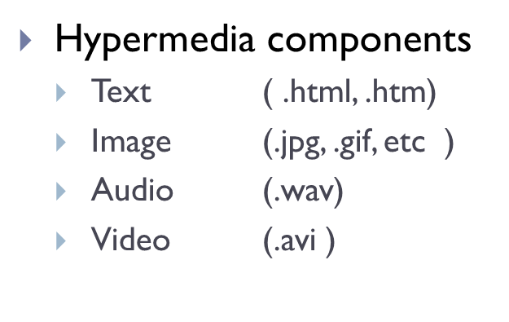  - Each Hypermedia component is a separate file  - Every file is downloaded separately in HTTP

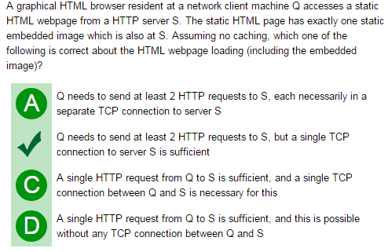

Methods Used in HTTP ( GET,POST )

 | GET | POST
Visibility/Bookmarked/Cached/History | Data is visible in URL . Can be Bookmarked ,cached and history remains in browser history | Data is not visible in URL . Cannot be Bookmarked ,cached and history do not remains in browser history
Restrictions on data length | Yes, when sending data, the GET method adds the data to the URL; and the length of a URL is limited (maximum URL length is 2048 characters) | No restrictions
Restrictions on data type | Only ASCII characters allowed | No restrictions. Binary data is also allowed
Security | Less Secure | More Secure

FILE TRANSFER ( FTP )

It is used to upload files to server and download files from a server. Requires 2 connections to the server.
Actual data – uses TCP port 20
Commands – uses TCP port 21

Difference between HTTP and FTP

1. FTP is a two-way system - It is used to upload files to server and download files from a server . HTTP, on the other hand, is strictly one-way transferring text, pictures and other data from the server to a web browser on a client computer

2. In FTP files are automatically copied or moved from a file server to a client computer's hard drive, and vice versa. On the other hand, files in an HTTP disappear when the browser is turned off unless the user executes commands to move the data to the computer's memory
3. FTP systems generally encode and transmit their data in binary sets which allow for faster data transfer. HTTP systems encode their data in MIME format which is larger and more complex

URL

Address Structure
protocol://username:password@domain_name:target_port/relative_path/file_name.extension#section
Example:- by deault 80 for http
http://www.tezu.ernet.in/dcsit/prog/mtech/index.html

protocol:http by default TOP
domain_name: www.tezu.ernet.in
relative_path: dcsit/prog/mtech
file_name: index
extension: html
Server Configutation Directives is present in /httpd.conf

EMAIL (SMTP & POP3)

POP3:- In order to receive e-mail messages POP3 is used .
SMTP:- In order to send e-mail client (if client want to send email to server) ,server(if server want to send email to client) uses SMTP

TCP, UDP
The TCP and UDP protocols are two different protocols that handle data communications between terminals in the Internet .

 | TCP | UDP
Reliability | TCP is connection-oriented protocol. When a file or message send it will get delivered unless connections fails. If connection lost, the server will request the lost part. There is no corruption while transferring a message. | UDP is connectionless protocol. When you a send a data or message, you don't know if it'll get there, it could get lost on the way. There may be corruption while transferring a message.
Ordered | If you send two messages along a connection, one after the other, you know the first message will get there first. You don't have to worry about data arriving in the wrong order. | If you send two messages out, you don't know what order they'll arrive in i.e. no ordered
Speed of transfer | The speed for TCP is slower than UDP.  TCP is suited for applications that require high reliability | UDP is faster  UDP is suitable for applications that need fast transmission, such as games
Header Size | TCP header size is 20 bytes | UDP Header size is 8 bytes.
Acknowledgement | Acknowledgement segments | No Acknowledgment

