Lecture -1

Transformation

Transformation means to change. There are 4 main types of transformations that one can perform in 2 dimensions.

- Translations
- Rotation
- Scaling
- Shearing
- Reflection

Translation : Translation moves the object form one position to another position in a straight line

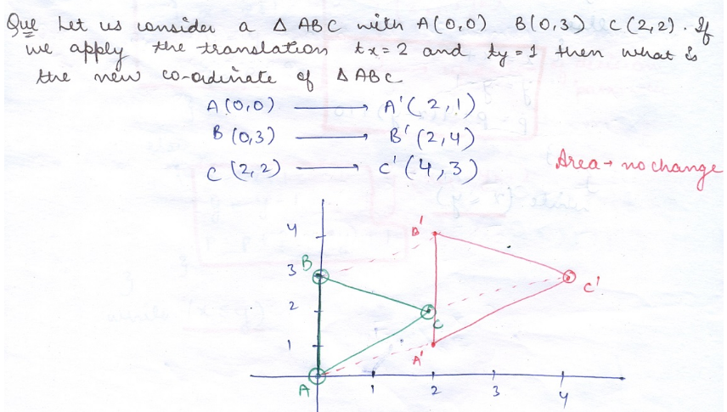

Roation

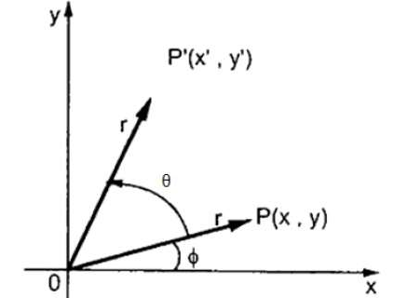
x=rcosϕ..... (1)
y=rsinϕ...... (2)

Same way we can represent the point P’ (X’, Y’) as
x′=rcos(ϕ+θ) = rcosϕcosθ − rsinϕsinθ.......(3)
y′=rsin(ϕ+θ)= rcosϕsinθ + rsinϕcosθ.......(4)

Substituting equation (1) & (2) in (3) & (4) respectively, we will get
x′=xcosθ−ysinθ
y′=xsinθ+ycosθ

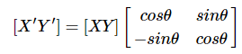
P’ = P . R
Where R is the rotation matrix
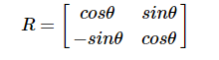 | For Anticlockwise rotation ( Positive Rotation )

For Clockwise rotation ( Negative Rotation ) replace θ by – θ
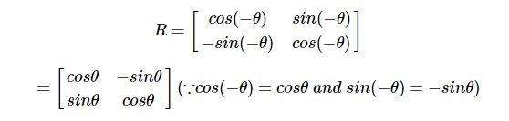

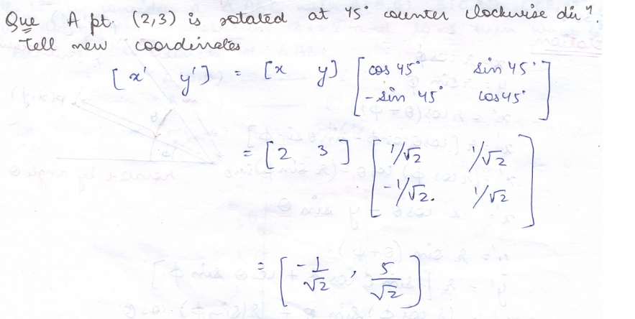

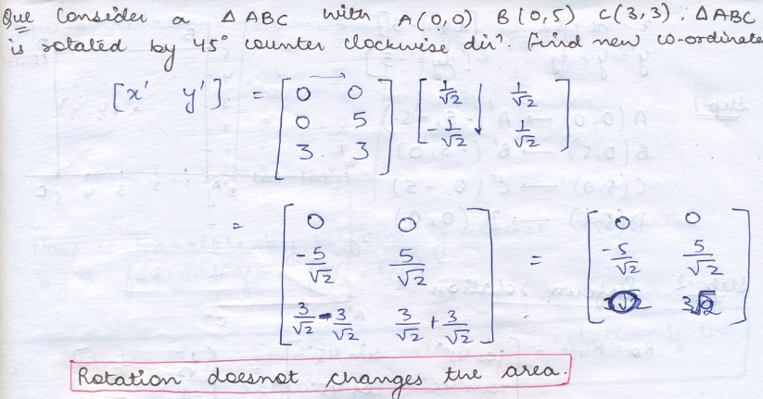

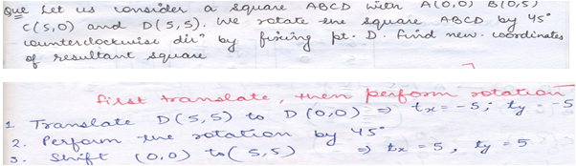
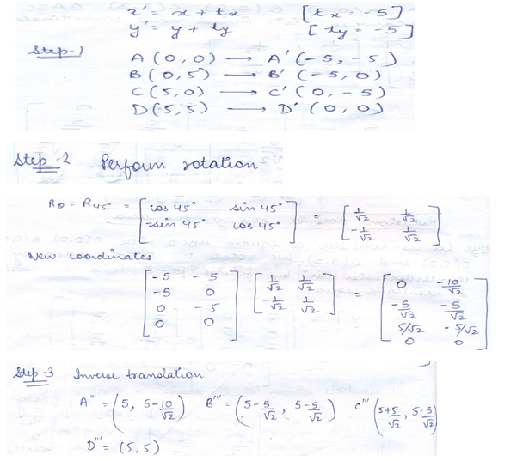

In the previous question fix the center of the square and perform the same rotation
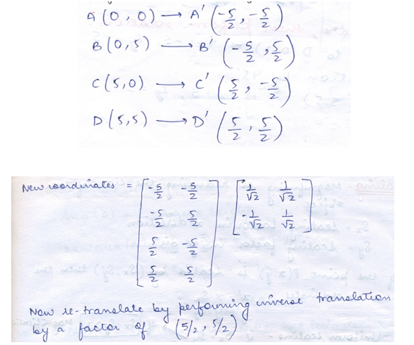

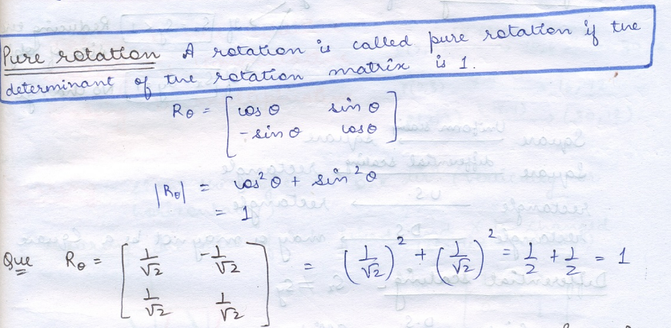

Lecture -2
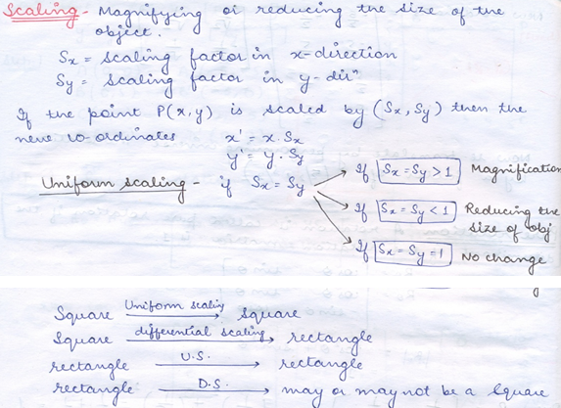
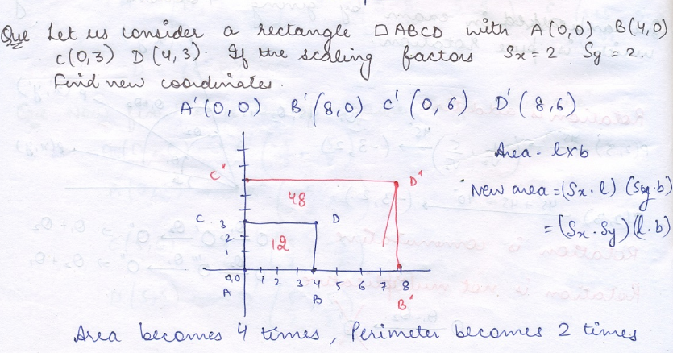

Shear
A transformation that slants the shape of an object is called the shear transformation. There are two shear transformations X-Shear and Y-Shear. One shift X coordinate’s values and other shifts Y coordinate values. Shearing is also termed as Skewing.
X-Shear

The X-Shear preserves the Y coordinate and changes are made to X coordinates
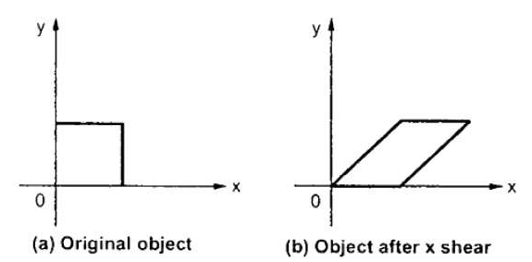
X' = X + Sh_{x}. Y
Y’ = Y
Y-Shear

The Y-Shear preserves the X coordinates and changes the Y coordinates
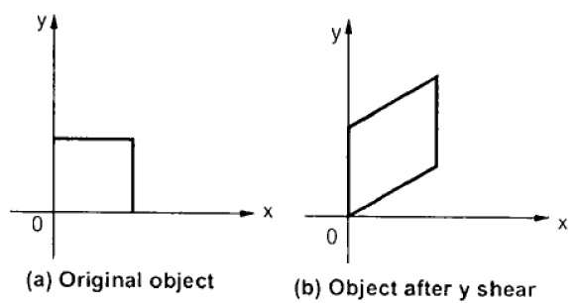
Y’ = Y + Sh_{y} . X
X’ = X

Reflection

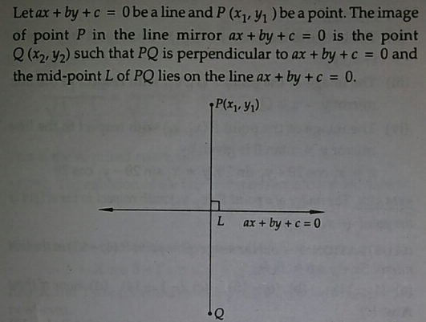
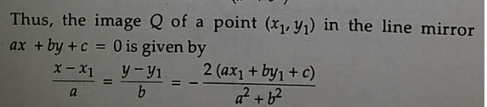

Note that there are two angles between the lines, an acute one and an obtuse one. To find acute angle b/w lines

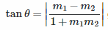

Slope of line b/w two points

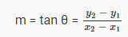

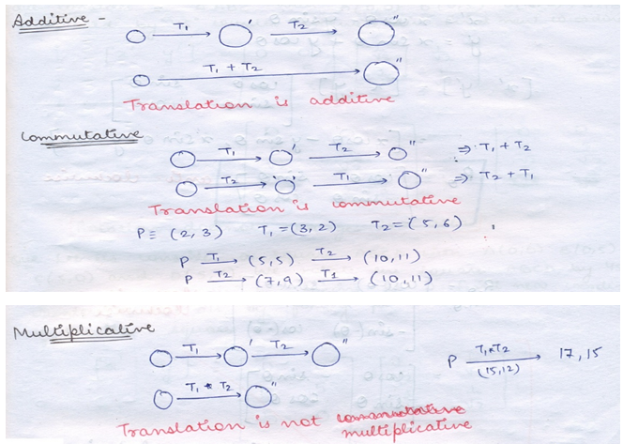
Similarly You can think about others like Rotation ,Scaling, Shearing, Reflection .

Lecture -3

Clipping and Viewing

Sometimes the complete picture of object in the world coordinate system is too large and complicate to clearly show on the screen, and we need to show only some part of the object.
To do so we take the help of window. A Window is a rectangular region in the world coordinate system.
When a window is "placed" on the world, only certain objects and parts of objects can be seen. Points and lines which are outside the window are "cut off" from view. This process of "cutting off" parts of the image of the world is called Clipping.

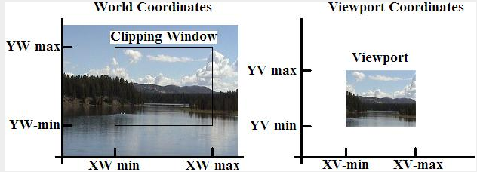

The scale factors ( Sx, Sy ) would be:
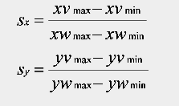

X_{v} – X_{vmin} X_{vmax} - X_{vmin}
---------------- = ---------------------
X_{w} - X_{wmin} X_{wmax} - X_{wmin}

Y_{v} - Y_{vmin} Y_{vmax} - Y_{vmin}
---------------- = ---------------------
Y_{w} - Y_{wmin} Y_{wmax} - Y_{wmin}

Q. Let the co-ordinates of point in real world are (6,8 ) .What are its coordinates in viewport .The widow size is given in diagram for both Real World and Viewport

10,10

4,4

Real World

20,20

15,15 15,15
ViewPort

Clipping

Point Clipping :-

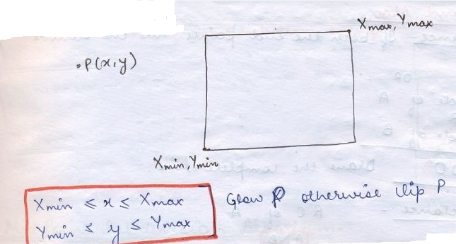

Lecture -4

Line Clipping :- Portion Outside the window is clipped

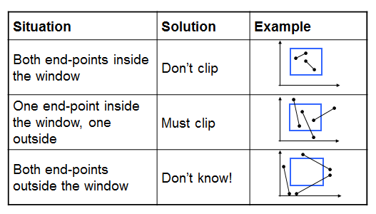

Cohen Sutherland Algo : -

It is used to fast the clipping process

4 bit code

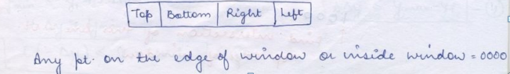

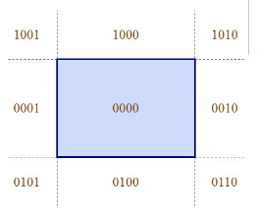

If both the endpoints have code 0000 : Draw complete line

If Code of one end point And Operation Code of other end point = Non Zero, it means line is completely outside the window . Clip it completely

If Code of one end point And Operation Code of other end point = Zero, it means line is completely outside the window or line is partially inside partially outside the window .

Lecture -5,6

Mid Point Subdivision Algorithm

Like Cohen Sutherland Algo line is tested for visibility. If the line is completely visible it is drawn and if it is completely invisible it is rejected.

The difference between these two algorithms is that in Cohen Sutherland Algo we have to calculate the intersection of line with the window edge . These calculations can be avoided by repetitively subdividing the line at its midpoint .The visibility test are then applied to each half. This subdivision process is repeated until we get completely visible or completely invisible line segment

The midpoint subdivision algorithm requires repeated subdivision of line segments and hence many times it is slower than using direct calculation of the intersection of line with the clipping window edge. However it can be implemented efficiently using Parallel architecture since it involves parallel operations

Liang-Barsky Line Clipping Algorithm

We will be using parametric equation of line

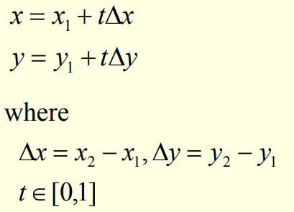

We know point lies inside the window if

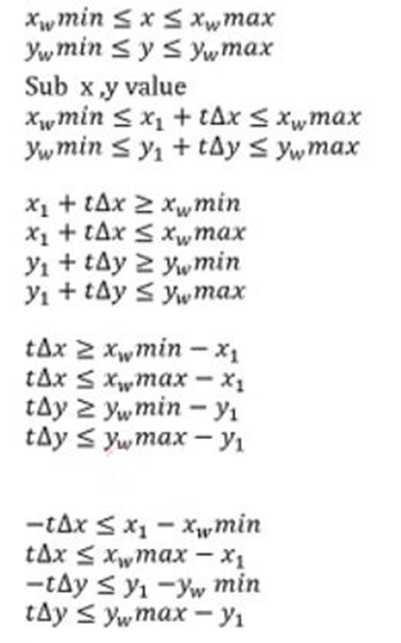

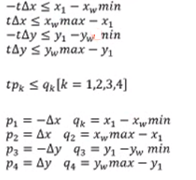

Initially we know t1=0, t2=1 .

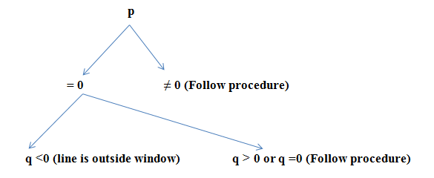

Check the value of p .

If any p value is zero then line is parallel to the window (may be inside, may be outside, may be on boundary) .Check the corresponding q

- q<0 (line is outside therefore no need to move further )
- q >0 (line is inside/partially inside)
- q=0 (line is within boundary / partially within boundary )

Procedure

For all p_{k}< 0 (The point is called potentially entering point ) find t1

t1=Max( 0 , q_{k /} p_{k} )

For all p_{k}> 0 (The point is called potentially leaving point ) find t2

t2= Min (1, q_{k /} p_{k} )

Once you get t1 and t2 check If t1 > t2 then line is completely outside therefore reject
Otherwise find the intersection points as

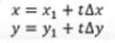

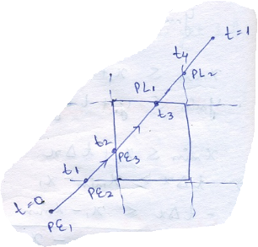

Lecture -7

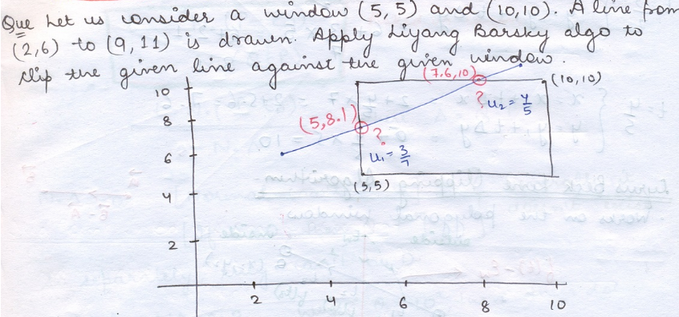

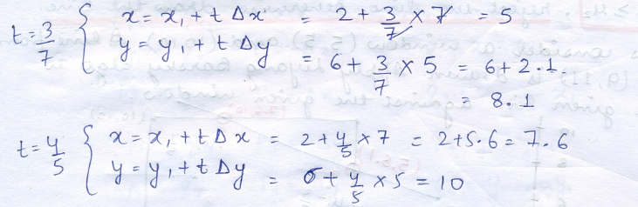

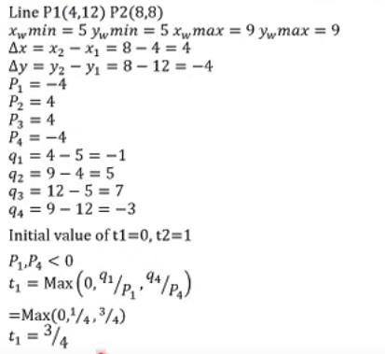
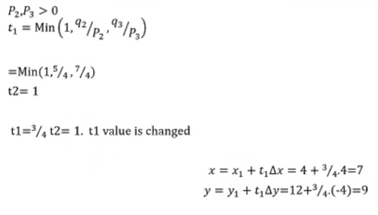

Lecture -8

Sutherland Hodgeman Polygon Clipping Algorithm

We know

1. Clipping of a polygon is also a polygon
2. If we know vertices of polygon after clipping in clockwise or anticlockwise order than we can draw the polygon .To obtain the same (vertices in clockwise or anticlockwise order ) we use the concept discussed in point No .3
3. For the given polygon start from any edge and move in clockwise or anticlockwise order until we finish all the edges of polygon and observe the following 4 conditions

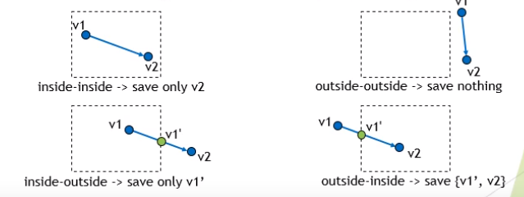
Starting vertex of edge is never saved, we will be saving only intersection point (always ) and last vertex (if it lies inside clipping window)

Weiler-Atherton Polygon Clipping Algorithm (Already discussed in class)

Lecture -9

- Translations
- Rotation
- Scaling
- Shearing
- Reflection

Translation

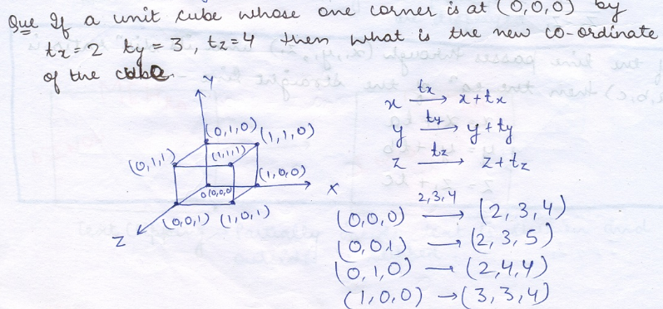
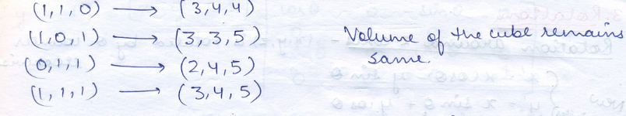

Rotation ( About any axis )

Where an object is to be rotated about an axis that is parallel to one of the coordinate axis. Z-axis rotation is same as the origin about in 2D for which we have the derived
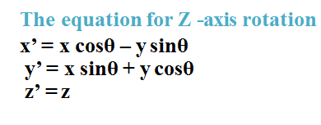
Obtain rotations around other axes through cyclic rotation
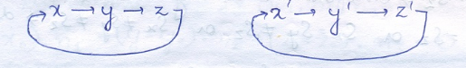
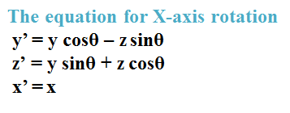
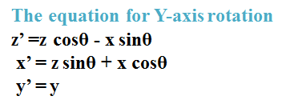

Scaling

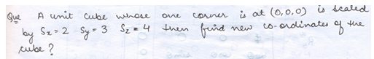
New volume = (2*3*4) * old Value
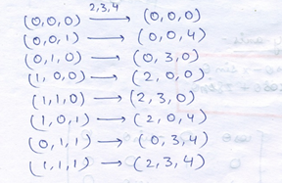

Shearing ( About Plane )

About xy plane i.e z=0 plane
x’= x+ Sh_{x} z
y’= y + Sh_{y} z
z’=z

Reflection

About any axis

Reflection about x-axis:-
x’=x y’=-y z’=-z
Reflection about y-axis:-
x’=-x y’=y z’=-z
Reflection about z-axis:-
x’=-x y’=-y z’=z

About Plane

Reflection about xy plane i.e z=0 plane
x’=x y’= y z’=-z
Reflection about yz plane i.e x=0 plane
x’= - x y’= y z’=z

Reflection about xz plane i.e y=0 plane
x’= x y’= - y z’=z

Lecture -10

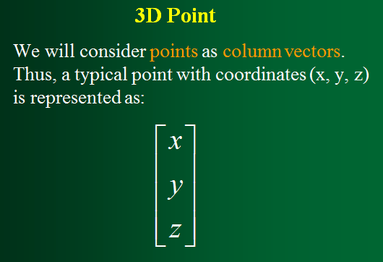
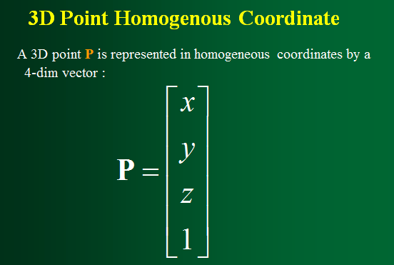

3D Homogeneous Coordinate

- We don't lose anything
- The main advantage: it is easier to compose translation and rotation
- Everything is matrix multiplication

