Please do revise the Discrete Structure topics mentioned below from your self
- Graph matching
- Articulation points and Biconnected components,
- Strong components,
Questions For Practice :
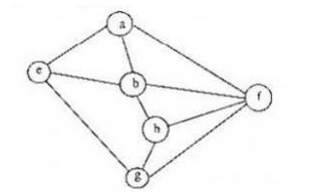
I. abeghf
II. abfehg
III. abfhge
IV. afghbe
Which are depth first traversals of the above graph?
A. I, II and IV only
B. I and IV only
C. II, III and IV only
D. I, III and IV only
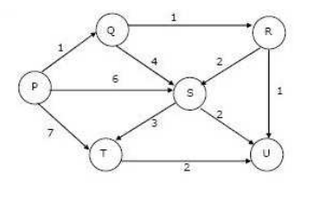
In what order do the nodes get included into the set of vertices for which the shortest path distances are finalized?( Apply Dijkstra’s starting at vertex P)
A. P,Q,R,S,T,U
B. P,Q,R,U,S,T
C. P,Q,R,U,T,S
D. P,Q,T,R,U,S
