Cellular Networks

It is an infrastructure network that give rise to the frequency reuse / channel reuse concept
- Given Area is divided into cells .
- Each cell has base station ( BS )
- Cell can be Equilateral Triangle or Square or Regular Hexagonal . But for the given range r of base station the area covered by hexagon is more than the area covered by the triangle or square, Therefore we will be using Hexagon cells .
- Mobile users attach to network through BS

Mobile User
Wired connection
Cell 1
Base Station (BS)

MSC

How Does Cellular System Work?
When a phone is turned on, it scans and selects the strongest signal sent by BSs

Channel Assignment Strategy

Fixed Channel Assignment
Each cell is assigned a predetermined set of voice channels. Any call attempt within the cell can only be served by the unused channel in that particular cell. If the channels in the cell are occupied the call is blocked, the user does not get the service. In a variation to this a cell can borrow channels from its neighboring cell if its own channels are full.
Dynamic Channel Assignment
Voice channels are not allocated to different cells permanently. Each time a call request is made, the BS requests a channel from MSC

Concept of Frequency reuse

- Adjacent cells must have different set of frequencies/channels to avoid interference (crosstalk).
- Cells are grouped into clusters. Each cluster uses the entire available radio spectrum . Therefore, the number of clusters is the number of times the entire spectrum can be used. This is called frequency reuse.
- Cells with the same number have the same set of frequencies
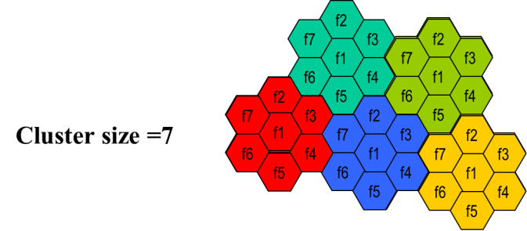
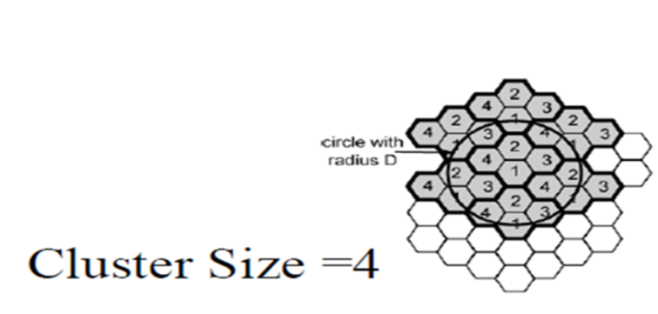

Handoff

Change of radio connection from one base station to other .There is two types of Handoff

- Hard Handoff  - Soft Handoff | 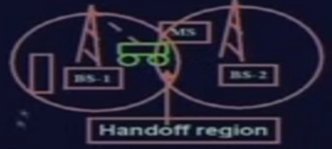

Hard Handoff :- Break before make . Mobile Station (MS) connects to BS-2 after link with BS-1 breaks
Soft Handoff:- Make before break .

Advantages of Hard Handover:
- Only one cannel is occupied at a time .
- It is very short and is usually not perceptible by the user
- In hard handover phone hardware does not need to be capable of receiving two or more channels in parallel, which makes it cheaper.
Advantages of Soft Handover:
It possess more reliable continuity with very less chance of call termination as comparison to hard handoff

