Convert given NFA to DFA
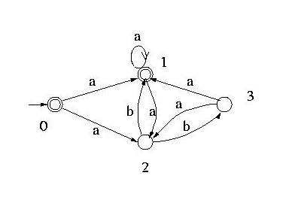
Minimze the given DFA

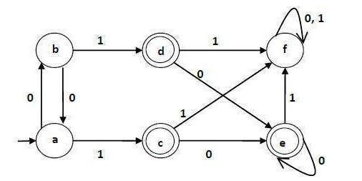
  - Draw a MFA which accepts the strings containing 1001 as substring

  - Draw a MFA which accepts the strings beginning with 101

  - Draw a MFA which accepts the strings ending with 110

